Disposable Respirators
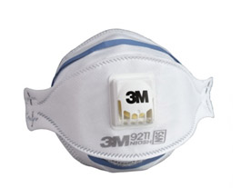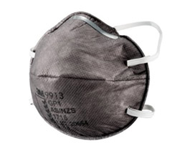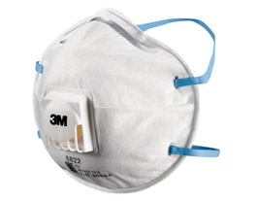

PARTICULATE RESPIRATORS ORGANIC VAPOUR RESPIRATORS WELDING RESPIRATORS

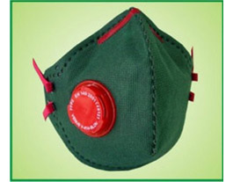

PAINTING RESPIRATORS

Emergency Life Saving Apparatus
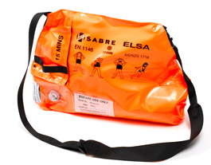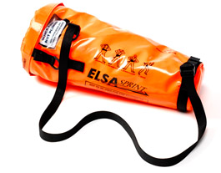

ELSA ELSA SPRINT

Power Air Purifying Respirator

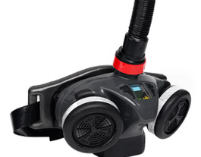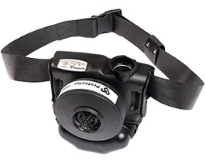

SPIRIT SX TORNADO

Reusable Respirators
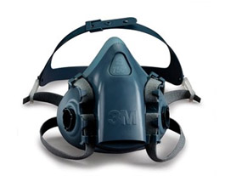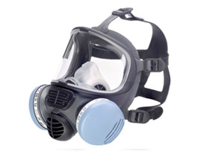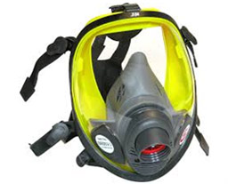

HALF FACE MASK FULL FACE MASK WITH CATRIDGE FULL FACE MASK WITH CANISTER

Self Contained Breathing Apparatus
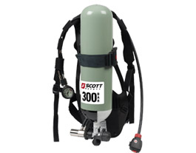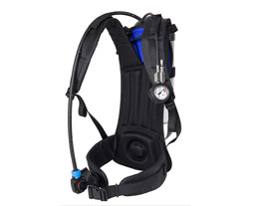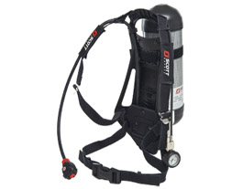

SIGMA 2 TYPE 2 ACSI PROPAK-SIGMA

Supplied Airpline Respiratory System

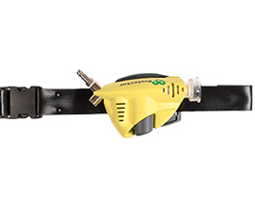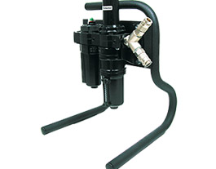

T-A-LINE AFU 300/600

